Hello everybody, My name is Sonali Sabnam
Welcome to the final presentation of ADTA 5560 Recurrent Neural Networks for Sequence Data. In this presentation we will discuss. All the points covered in the final project. And the final project covers all the topics discussed during this course.
Before we proceed.
I would like to thank and express my gratitude to Doctor Win for his continuous support and guidance throughout the course, which lead to successful completion of this course and the project.
I had a great experience while working on the assignments and the final project.
Now let us begin with the presentation.

Slide 2
- Introduction
- PART I: A Time-series Data Set
- PART II: RNN: Simple RNN with Sine Wave Data
- PART III: RNN: LSTM Neural Network
- PART IV: RNN: LSTM with Time-Series Data
- PART V: Redesign the Neural Network
- PART VI: Compare Network Performance
- PART VII: Project Report
- Conclusion
In the agenda we will do a brief introduction of the project.
I will About part I, where we worked on a time series data set and understood the details.
In Part 2, We worked on a simple RNN with sine wave data.
For Part 3, we discussed about the RNN LSTM, limitations of Simple RNN and how LSTM can solve the issues with Simple RNN.
In part 4, we design an LSTM neural network 2 Forecast time series data.
Part 5 We redesigned the RNN LSTM with an Intent to Improve the performance of the model.
In Part 6, We compared the performance of both the networks which were developed in Part 4 and Part 5 To understand which was the better network.
In part 7, we worked on a detailed report of what we have done in the project, what we have learned and what was the experience while working with these models.
Finally, we conclude the presentation.

Time: 1.57mins

Slide 3:

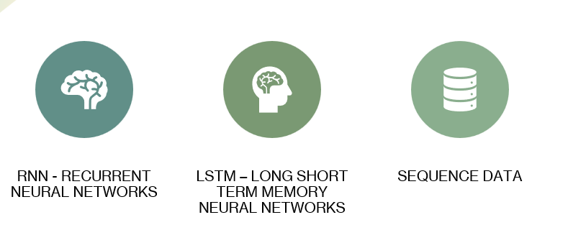
This course focuses on 3 major components which are Recurrent Neural network, long short term memory Neural networks and sequence data. The sequence data primarily involves the Sine wave data and time series data.
Recurrent neural network is a strong and powerful model to predict sequence data. However, there are a certain limitations with the simple RNN.
We have tried to discuss in detail about these limitations.
The answer to these limitations is LSTM. In This project we have tried to understand how LSTM can solve the limitations of Simple RNN and we have built a powerful Prediction model for Time series data.
The various parts of the project focus primarily on these 3 Components which are RNN, LSTM and sequence data.

Slide 4:
Part one is about a time series data set. And the task that we were supposed to do as part of this exercise are:
--) Search on the Internet, using Google search or any other approach, to find a time-series dataset in the public domain, i.e., available for use without restrictions.
--) This dataset may contain either numeric values or multimedia data, including text, images, videos, and audio files.
- Name: Olson Utah Time Series
- Data Type: Time Series
- Source: data.gov
- Timeseries Span: Hourly Data for O3 and NoX formation
  - Start time: 29-01-2017 00:00:00
  - End time: 02-02-2017 23:00:00
- Data Points: 120 rows
The data set has four fields with one Categorical data and three numerical data

Time: 4.20
Slide 5:
In part II of the project: Simple RNN with sine wave data,
A Sine wave is created with 1080 evenly spaced values in the range of 0 and 60 and used as a dataset for building the Simple RNN network.
The Model Architecture includes:
A sequential model,
A simple RNN layer with 100 new ones. One input feature. Which is the X axis value of the sine wave. A fully connected then Slayer with one neuron which serves as the output of this model 2 Predict the next value in the sequence based on the input.
This slide shows the architecture of the model. And the Plot of the sine wave data which is generated. As part of this exercise and used as the data set.
Time: 5.21
Slide : 6
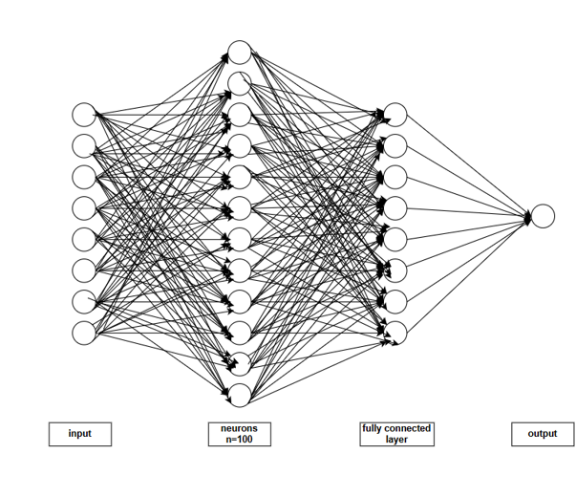
This slide shows the architecture diagram of the simple recurrent neural network which is Build for Part 2. As we can see here, there is an input layer. A simple RNN layer with 100 nuerons. There is also one fully connected layer. It works as the output layer to predict the next value in the sequence based on the input.
For the sake of simplicity, we have limited the number of neutrons represented in this diagram. However, the actual model has 100 neurons in the simple RNN layer.
Though the model is called Simple RNN, The diagram Clearly shows the complexity involved in it.
Time 8.13
Slide 9:
PART III: RNN: LSTM Neural Network
Simple Recurrent Neural Network are designed to efficiently process the sequential data. However, there are some limitations with the Simple RNN which include.
Vanishing Gradient Problem:
- During back propagation, recurrent neural networks suffer from the vanishing gradient problem.
- Gradients are values used to update weights that are applied to a neural network.
- A gradient measures how much the output of a function changes if you change the inputs a little bit.
- The gradient shrinks as it back propagates through time.
- If a gradient value becomes extremely small, it stops contributing to the network’s learning.
- In other words, the neural network stops learning.
- Layers that get a very small gradient update stops learning.
- Those are usually the earlier layers in the network and these layers don’t learn.
- RNN’s can forget what it has seen in the earlier time steps of long sequences, thus having a short term memory due to the problem of vanishing gradient.
Exploding Gradient Problem:
- Exploding gradient problem is contrary to Vanishing Gradient problem.
- It occurs when the gradient becomes too large during the backpropagation.
- In this case the weights become too large and the network starts to diverge.
- This causes difficulty for the model to learn the underlying pattern in the data.
- This is often the result of gradients greater than 1, leading to a rapid increase in values as we propagate them backward through the layers.
Short Term Memory:
- The hidden state of the memory gets updated in each step so the previous information in no longer retained.
- If a sequence is long, it’s hard for RNN’s to “memorize” the information at earlier time steps.
- The loss function outputs an error value that estimates the network performance.
Last, it uses the generated error value to perform back propagation.
Time: 10.47

Slide 10:
LSTM (Long Short Term Memory) neural network is considered as a powerful solution to the Vanishing and exploding gradient problem of the simple neural network.
Introduction:
In the mid-90s, Sepp and Juergen (German researchers) proposed the Long-Short-Term Memory (LSTM) neural network as a solution to the vanishing gradient problem.
Details:
- The LSTM network can preserve the gradient along the path of backpropagation through time and layers.
- It maintains a more constant gradient while backpropagation is done.
- The neural network can continue learning over many time steps.
- LSTM Cell State:
  - It sCan transfer information from the earliest time steps all the way to the end of the sequence chain.
  - It can carry relevant information throughout the processing of the sequence.
  - Can mitigate the problem of short-term memory.
Slide 11
- LSTM Gates:
  - LSTM cell uses the gates to regulate the flow of information moving along the path of processing the sequence chain.
  - There are three gates: Forget, Input, and Output in an LSTM Cell, each with one sigmoid activation function.
  - Each gate is a neural network that can learn to determine what information should be relevant or significant and then be used.
  - Each gate can learn to decide, during the training on what information to keep because it is relevant and which information to “forget” because it is irrelevant or insignificant.

Slide 12
This slide shows the architecture and configuration of an LSTM model designed for time-series data analysis.
The model comprises three stacked LSTM layers, each with 50 neurons, utilizing the ReLU activation function.
The return_sequences=True parameter enables stacking, ensuring sequence outputs are propagated.
Two dropout layers, each with 20% regularization, help mitigate overfitting.
The input sequence length is set to 60, with a batch size of 32 and 100 epochs for training.
The table details the model layers, output shapes, and parameter counts, illustrating the complexity of each layer.
This design captures temporal dependencies effectively, demonstrating the strength of LSTMs in time-series forecasting.
Slide 13
This slide showcases the Loss Function plot, which demonstrates the model's learning progress over 100 training epochs.
The y-axis represents the loss value, while the x-axis denotes the number of epochs.
A sharp decrease in the loss is observed at the beginning, indicating rapid learning.
The loss then stabilizes, signifying convergence to an optimal solution. This steady decline and eventual plateau reflect effective training and minimal overfitting.
Such insights are vital for assessing model performance and ensuring it generalizes well to unseen data.
Slide 14
This slide presents a Forecasted Data plot, showcasing predicted trends over a specific range. The x-axis represents the time or sequence, while the y-axis indicates the forecasted values.
The curve highlights key patterns, including an initial sharp increase peaking around 520, followed by cyclical fluctuations.
These insights are crucial for understanding potential future behavior and making informed decisions based on predicted trends.
The plot can be used to validate forecasting model accuracy and identify trends such as growth, decline, or stabilization in the observed data.
Slide 16
This slide illustrates Actual and Forecasted Data for stock prices from 2022 to 2024.
The blue line represents the historical Close Price, capturing past fluctuations and trends, while the orange line indicates the Forecasted Price, projecting future movements.
The model effectively captures the historical trend and predicts a stabilization in the near future.
Such analysis is instrumental in identifying potential market behavior, aiding in strategic financial planning and investment decisions.
The comparison between actual and forecasted data validates the model's accuracy and reliability for predicting future trends.
Slide 17
This slide discusses the redesign of a neural network, focusing on a stacked Long Short-Term Memory (LSTM) architecture.
The network consists of four LSTM layers, each with 60 neurons and ReLU activation.
To enable stacking, the return_sequences=True parameter is utilized. Regularization is incorporated through three dropout layers, applied after each LSTM layer, with a 20% dropout rate to prevent overfitting.
The model processes input sequences of length 60, with a batch size of 32 for training.
It is trained for 100 epochs, balancing computational efficiency and accuracy.
This design enhances the model's performance on sequence-based tasks.
Slide 18
This slide presents the training loss curve for the redesigned neural network. The graph illustrates the decrease in the loss value over 100 training epochs. Initially, the loss starts at a high value, reflecting the model's poor initial predictions. However, it rapidly decreases during the early epochs, indicating effective learning and optimization of the model's parameters. Beyond epoch 20, the loss stabilizes with minor fluctuations, suggesting convergence and a reduced rate of improvement. The consistent decline in loss highlights the model's ability to generalize well to the training data. This curve is a key indicator of the network's training performance.
Slide 19
This slide illustrates the forecasted data produced by the redesigned neural network. The graph showcases the model's ability to predict trends and fluctuations within the dataset. The x-axis represents the sequence or time steps, while the y-axis indicates the predicted values. The curve captures a significant decline followed by a sharp rise, reflecting the variability in the underlying patterns. The smoothness of the curve suggests the model's effective handling of the data without overfitting or noise amplification. These results demonstrate the model's applicability in forecasting scenarios, providing insights into temporal dynamics for informed decision-making.
Slide 20
This slide illustrates the forecasted data produced by the redesigned neural network. The graph showcases the model's ability to predict trends and fluctuations within the dataset. The x-axis represents the sequence or time steps, while the y-axis indicates the predicted values. The curve captures a significant decline followed by a sharp rise, reflecting the variability in the underlying patterns. The smoothness of the curve suggests the model's effective handling of the data without overfitting or noise amplification. These results demonstrate the model's applicability in forecasting scenarios, providing insights into temporal dynamics for informed decision-making.

Slide 21:
This section presents a comparison between two Long Short-Term Memory (LSTM) Recurrent Neural Network (RNN) models, highlighting their design differences and performance metrics:
Comparison of Model Configurations
- Percentage of Data for Testing: Both models allocate 10% of the dataset for testing, ensuring consistency in evaluation.
- Layers of LSTM:
  - Model Part IV: 3 layers
  - Model Part V: 4 layers
- Number of Neurons per LSTM Layer:
  - Model Part IV: 50 neurons
  - Model Part V: 60 neurons
- Dropout Layers:
  - Model Part IV: 2 layers
  - Model Part V: 3 layers
- Percentage Dropout: Both models utilize a dropout rate of 20% to prevent overfitting.
- Length of Input Sequence: Both models use an input sequence length of 60 time steps, maintaining uniformity.
- Batch Size: Both are trained with a batch size of 32.
- Number of Epochs: Training for both models is conducted over 100 epochs.
Performance Metrics
- Training Loss:
  - Model Part IV: 0.0025
  - Model Part V: 0.0032
  - Interpretation: Model Part IV achieves a slightly lower training loss, indicating better performance during training.
- Forecasting Loss (Testing):
  - Model Part IV: 0.0017
  - Model Part V: 0.0027
  - Interpretation: Model Part IV demonstrates better generalization for forecasting on testing data.
Key Takeaways
- Increasing the complexity of the model (e.g., more layers, neurons, and dropout layers) may lead to slightly higher training and testing loss.
- Model Part IV, with a simpler design, shows better overall performance in terms of both training and forecasting loss, suggesting that over-complication might not always lead to better results.

I would like to extend my heartfelt gratitude to Professor Win for the incredible learning experience in ADTA 5560. The course was both insightful and engaging, providing me with valuable skills and knowledge.
I thoroughly enjoyed the thoughtfully designed assignments, which challenged me to think critically and apply concepts to practical problems. These exercises significantly enhanced my understanding of the subject.
The final project was a standout aspect of the course, offering a hands-on opportunity to synthesize everything I had learned. It was not only a rewarding experience but also a chance to explore real-world applications of the techniques taught in class.
Thank you, Professor, for your dedication, clear explanations, and continuous support throughout the semester. Your passion for the subject has been truly inspiring, and I am grateful for the opportunity to have been a part of this learning journey.

